WriteUp Conway's trap(revesere)

题目信息+题目名称

解题思路（详细介绍+有截图）
1. 文件基本信息
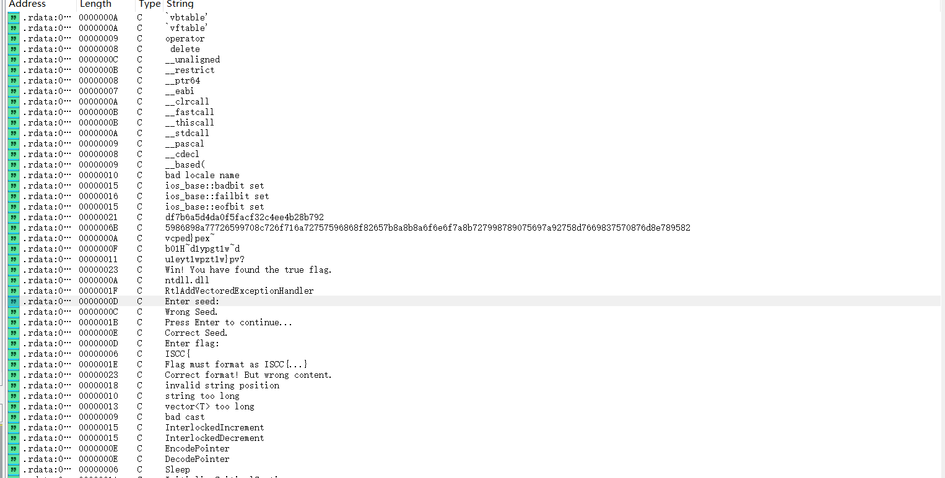
使用exeinfope查壳，确认是VC++编译的32位PE程序，未加壳。拖进IDA Strings窗口可以看到程序的主要交互提示："Enter seed:"、"Correct Seed."、"Wrong Seed."、"Enter flag:"、32字节的"df7b6a5d4da0f5facf32c4ee4b28b792"和106字节的长hex串。

2. 主函数
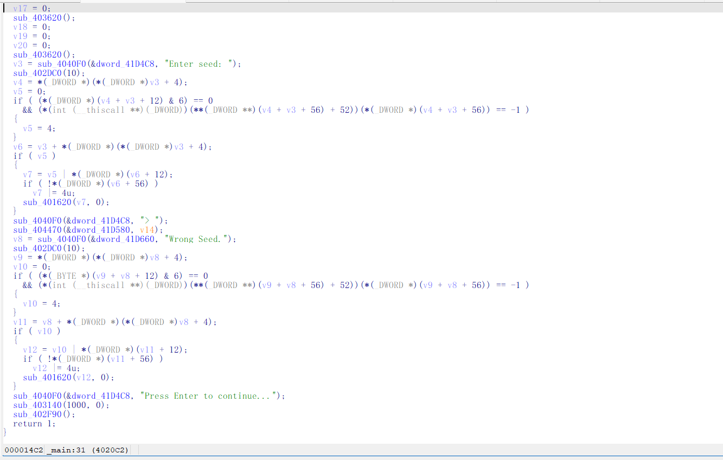
_main反编译：先读seed，再读flag（要求ISCC{...}格式），sub_401C10负责提取花括号内容。校验逻辑分布在sub_401990、sub_401D00等多个函数中。
3. 16字节状态变换
sub_401990实现了16字节状态的轮变换。每轮将16字节分成8对，对每对做：a' = (a+b)&0xFF，b' = rotl((a+b)^b,1)。然后整体左移1字节。共执行5轮。32字节hex串"df7b6a5d4da0f5facf32c4ee4b28b792"是5轮变换后的终态。变换可逆，从终态逆推5轮即可恢复原始seed。
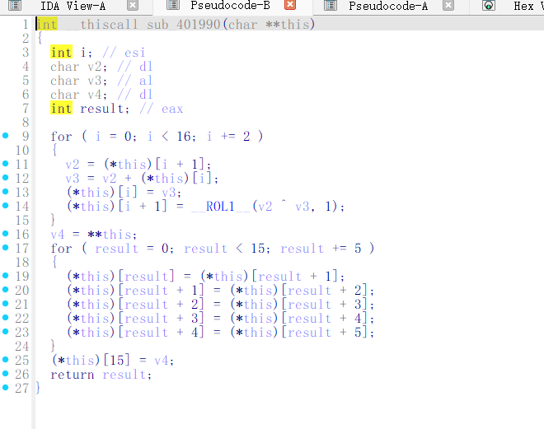

4. 隐藏的flag校验
sub_401D00中有连续的内存赋值指令（c7 45 xx），存放的常量被0xCC异或隐藏。还原后的23字节校验数据与seed配合解码flag。核心公式：check[i] = ROL3(((seed[i&0xF] XOR flag[i]) + i*23) & 0xFF) XOR 0xAA。反向即可解出flag各字节。

5. 求解
Python脚本：提取seed终态->逆推5轮->提取隐藏校验表->解码flag。
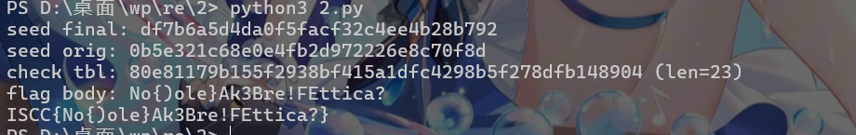
最终flag：ISCC{No{)ole}Ak3Bre!FEttica?}

Exp
import os, re, sys

data = open(sys.argv[1] if len(sys.argv) > 1 else "Conway's Trap.exe", "rb").read()

# ---- locate seed final state ----
found = None
for h in re.finditer(rb'(?<![0-9A-Fa-f])([0-9A-Fa-f]{32})\x00', data):
x = bytes.fromhex(h.group(1).decode())
if len(x) == 16:
found = x
break
if found is None:
print("cannot locate seed"); exit(1)

print("最终的种子:", found.hex())

# ---- revert 5 rounds ----
cur = found
for _ in range(5):
# shift right (opposite of original shift-left)
r = bytearray(16)
r[0] = cur[15]
r[1:] = cur[:15]
nxt = bytearray(16)
j = 0
while j < 16:

aa = r[j]
bb = r[j + 1]
# rotl((a+b)^b, 1) = bb → (a+b)^b = rotr(bb, 1)
# let s = a+b = aa → b = aa ^ rotr(bb, 1)
# a = aa - b
rev_b = aa ^ (((bb << 7) | (bb >> 1)) & 0xFF)
rev_a = (aa - rev_b) & 0xFF
nxt[j] = rev_a
nxt[j + 1] = rev_b
j += 2
cur = bytes(nxt)

seed = cur
print("seed orig:", seed.hex())

# ---- verify ----
v = seed
for _ in range(5):
t = list(v)
k = 0
while k < 16:
sm = (t[k] + t[k + 1]) & 0xFF
t[k] = sm
t[k + 1] = ((sm ^ t[k + 1]) * 2 + ((sm ^ t[k + 1]) >> 7)) & 0xFF
# same as rotl((sm ^ t[k+1]), 1) but avoids function call
k += 2
v = bytes(t[1:] + t[:1])
if v != found:
print("verify failed"); exit(1)

# ---- extract hidden constants ----
pat = re.compile(
b'\xc7\x45\xe4(....)'
b'\xc7\x45\xe8(....)'
b'\xc7\x45\xec(....)'
b'\xc7\x45\xf0(....)'
b'\xc7\x45\xf4(....)'
b'\x66\xc7\x45\xf8(..)'
b'\xc6\x45\xfa(.)', re.S)
m = pat.search(data)
if m is None:
print("check table not found"); exit(1)

raw_tbl = b''.join(m.groups())
tbl = bytes([b ^ 0xCC for b in raw_tbl])
print("check tbl:", tbl.hex(), f"(len={len(tbl)})")

# ---- decode flag ----
nn = len(tbl)
res = []
for p in range(nn):
vv = tbl[p]
# ROR3 = (vv ^ 0xAA) >> 3 | (vv ^ 0xAA) << 5
xored = vv ^ 0xAA
ror3 = ((xored >> 3) | (xored << 5)) & 0xFF
subbed = (ror3 - (p * nn)) & 0xFF
res.append(seed[p & 0x0F] ^ subbed)

body = bytes(res).decode()
print("flag body:", body)
print("ISCC{" + body + "}")

